**Notes:**

I completed the “Easy” part of the assignment completely. I made an effort to complete the “Moderate” and “Hard” assignments. In the “Moderate”, I was unable to figure out the color conditional for the yearly change. For “Hard”, could not figure out how to do the Max/Min. In the code file, I provided the color conditional and Max/Min codes that I was working on set seperately. I would like to see the completed code for the assignment, so I can review later. Thanks.

**2016**

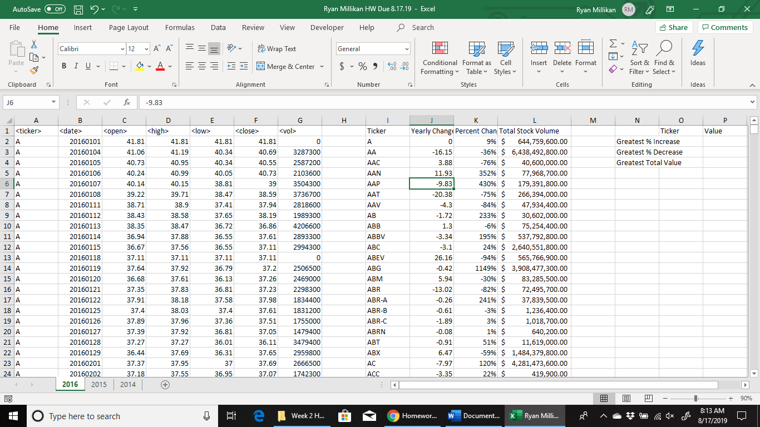

**2015**

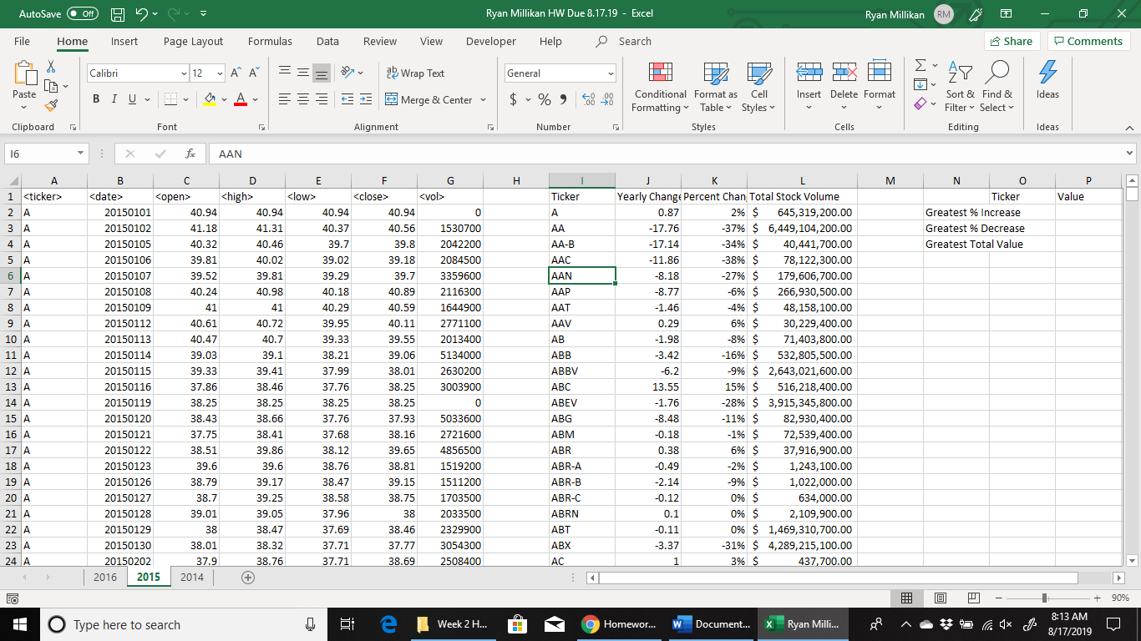

**2014**

